Test case | First | Second | Expected results
#1 | 14 | 7 | 7
#2 | 12 | 8 | 4
#3 | 16 | 4 | 4

First test
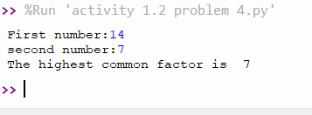

Second test
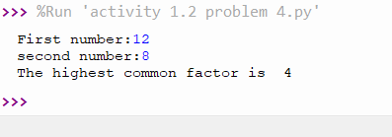
Third test
